Exp 1: Solve 8-Puzzle Problem
Aim:
To write a Python program to solve the 8-puzzle problem.

Objective:
- To understand the 8-Puzzle problem.
- To represent the puzzle using a 3×3 matrix.
- To move the blank tile (0) step by step.
- To display the sequence of puzzle states from the initial state to the final state.

Algorithm:
- Start the program.
- Store the initial puzzle state.
- Display the initial puzzle.
- Move the blank tile (0) to the next valid position.
- Display the updated puzzle state.
- Repeat the process until the final puzzle state is reached.
- Display the final puzzle state.
- Stop the program.

Pseudocode:
START
Display "Initial State"
Store the initial puzzle
Print the puzzle
WHILE final state is not reached
Move the blank tile (0)
Display the new puzzle state
END WHILE
STOP

Program:
print("Initial State")
puzzle = [
[1,2,3],
[5,6,0],
[7,8,4]
]
for row in puzzle:
print(*row)
print("\nStep 1")
puzzle = [
[1,2,3],
[5,0,6],
[7,8,4]
]
for row in puzzle:
print(*row)
print("\nStep 2")
puzzle = [
[1,2,3],
[5,8,6],
[7,0,4]
]
for row in puzzle:
print(*row)
print("\nStep 3")
puzzle = [
[1,2,3],
[5,8,6],
[0,7,4]
]
for row in puzzle:
print(*row)

Input:
[1,2,3]
[5,6,0]
[7,8,4]

Output:
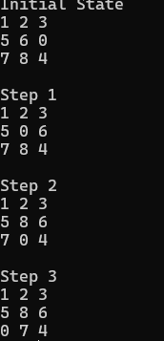

Result:
Hence, the Python program to solve the 8-Puzzle problem was executed successfully and the output was verified.

